Implied Subject

✅ What is Implied Subject
# Source: AI Source: Provided by: [Data Path: Persons Table -> ID Column: 1, Name_En Column: Motasem Essam] -> From: [Chatgpt (GPT-4-turbo)] on [8/4/2025]
An implied subject (also called an understood subject) is a subject that is not stated explicitly in the sentence but is understood from context, typically in imperative sentences (commands or instructions).
The subject is you, but it’s left out because it’s obvious.

🔹 Common Context:
# Source: AI Source: Provided by: [Data Path: Persons Table -> ID Column: 1, Name_En Column: Motasem Essam] -> From: [Chatgpt (GPT-4-turbo)] on [8/4/2025]
- Imperative sentences
- Commands, requests, or instructions
- Spoken or written in direct address

🔹 Structure:
# Source: AI Source: Provided by: [Data Path: Persons Table -> ID Column: 1, Name_En Column: Motasem Essam] -> From: [Chatgpt (GPT-4-turbo)] on [8/4/2025]
- Base verb form without an explicit subject
- Subject (you) is understood

🔹 Examples:
# Source: AI Source: Provided by: [Data Path: Persons Table -> ID Column: 1, Name_En Column: Motasem Essam] -> From: [Chatgpt (GPT-4-turbo)] on [8/4/2025]
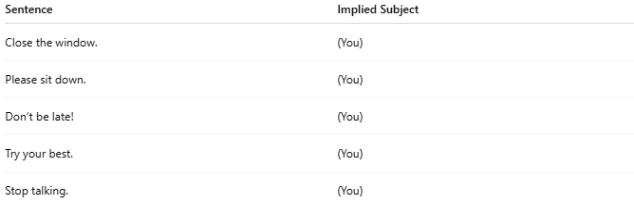

Sentence | Implied Subject
Close the window. | (You)
Please sit down. | (You)
Don’t be late! | (You)
Try your best. | (You)
Stop talking. | (You)

🔍 How to Identify:
# Source: AI Source: Provided by: [Data Path: Persons Table -> ID Column: 1, Name_En Column: Motasem Essam] -> From: [Chatgpt (GPT-4-turbo)] on [8/4/2025]
- If it’s a command, request, or direction…
- And there’s no stated subject…
- Then the subject is likely implied "you"

🔁 Compare:
# Source: AI Source: Provided by: [Data Path: Persons Table -> ID Column: 1, Name_En Column: Motasem Essam] -> From: [Chatgpt (GPT-4-turbo)] on [8/4/2025]
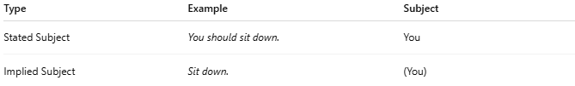
Type | Example | Subject
Stated Subject | You should sit down. | You
Implied Subject | Sit down. | (You)

